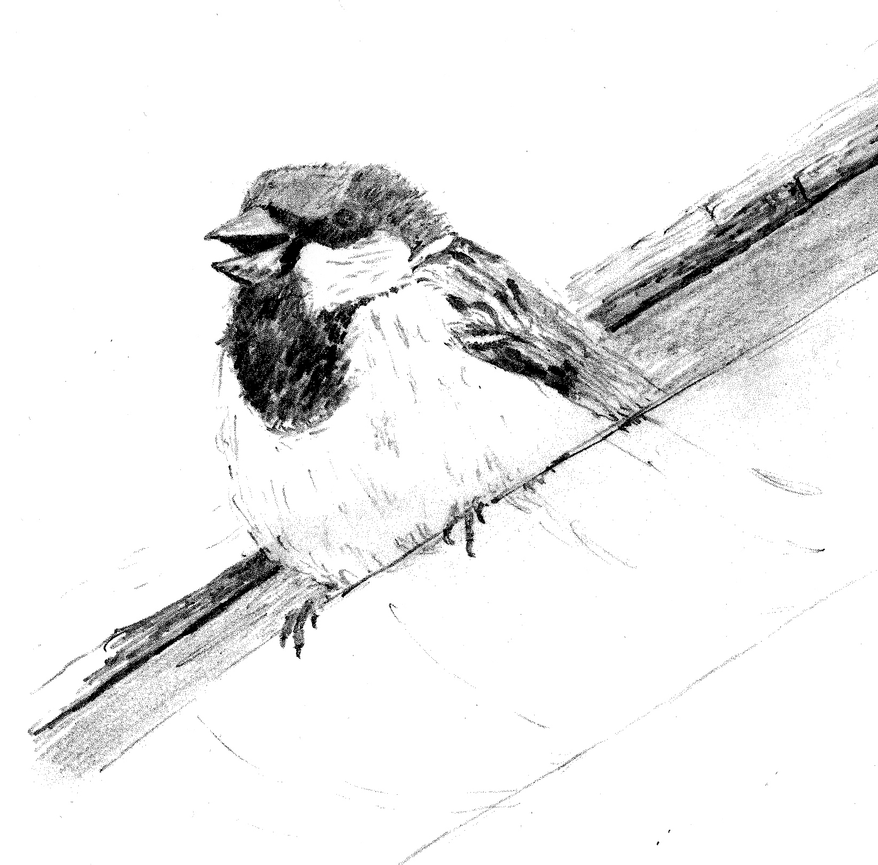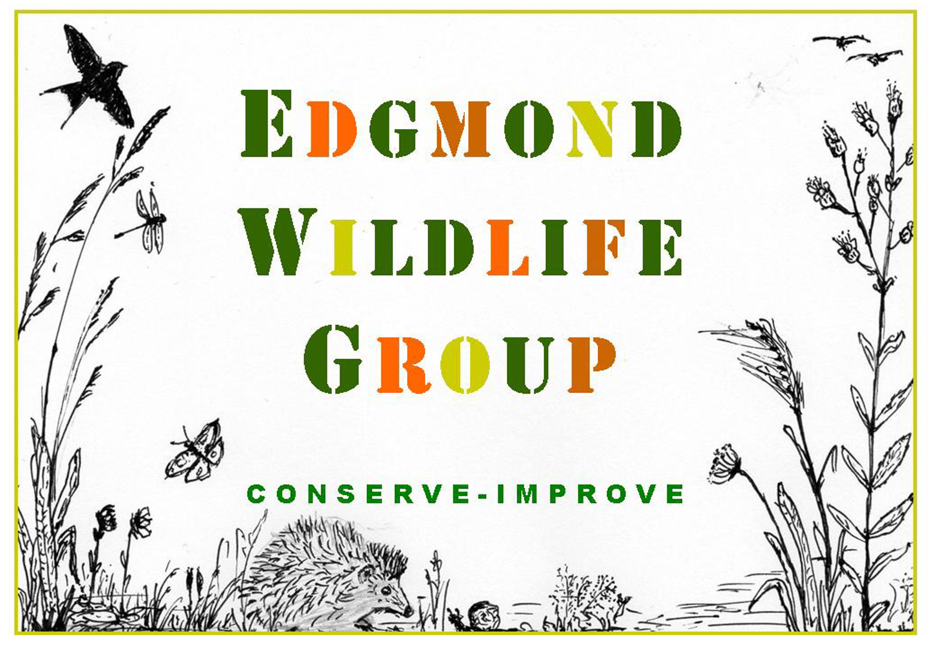EDGMOND WILDLIFE GROUP

GIFT MEMBERSHIP & INFORMATION FORM

This form is only to be used by those people who have been given **a gift membership card**.

|  |
| --- |
| **EDGMOND WILDLIFE GROUP was formed** in the Spring of 2020 when we came together with a shared concern about the crisis facing the natural world. Our first and most important project was to re-imagine the Church Field as a beautiful area in which wildlife could thrive. |
| **WHAT DO WE BELIEVE IN?** We believe that we can all help make Edgmond more wildlife friendly. From gardening more sustainably to hedge & tree planting; from visits to nature reserves to working at the local school; all these activities will help encourage us to be more aware of wildlife on our own patch. |
| **WHAT DO WE DO?** We take on practical projects in our local area. We want to inspire others to learn more about wildlife and the environment, and to demonstrate that even small changes can make a big difference. We want everyone to think about nature first! |
| **WHY JOIN US?** You will be helping us to continue with our local activities such as maintaining the Church Field; providing support to St Peter’s School; working with HAU, and controlling the spread of Himalayan Balsam. We regularly call for volunteers to help with projects. It doesn’t matter if you prefer to remain a ‘sleeping’ member’! |
| **WHAT WILL I GET OUT OF BEING A MEMBER?** You will be helping to make Edgmond a more wildlife friendly place. You could join work parties & occasional ‘behind the scenes’ trips to local nature reserves, or join guided walks. You can share your wildlife photographs or sightings. Occasional ‘Wildlife Roundups’ for the Edgmond area are sent out by email. You could join the Committee! |
| **HOW CAN I FIND OUT MORE?** We communicate directly with you via email. We also have a website, a Facebook Page and a presence on the social media platform Nextdoor Edgmond.  <https://www.edgmondwildlife.com/>  <https://www.facebook.com/groups/edgmondwildlifegroup>  <https://nextdoor.co.uk/g/805mh3pvh/?init_source=search&query=Edgmond%20wildlife%20group> |
| **WHAT NEXT? Please fill out the form below. All personal information will be held in accordance with current data protection guidelines.**   |  |  | | --- | --- | |  |  |   **NAME(S) OF ADULT(S):**  **ADDRESS & POSTCODE:**  **EMAIL ADDRESS(ES):**  **PREFERRED PHONE NUMBER:**  **EITHER RETURN by post/by hand to**: **Edgmond Wildlife Group, 1A Connors Lane, Edgmond**  **OR RETURN by Email to: edgmondwildlife@gmail.com** |
| You may prefer to complete a **digital version** and send by email. If so, then you will find a gift membership form on our website **edgmondwildlife.com**. There is a link at the top on the first page. You can also find this form on Facebook on our **Edgmond Wildlife Group** Page at the top, under FILES.  **Note: Membership is renewed on June the 1st. If you were gifted membership between 1st January to 1st June, these months are free, your membership will need to be renewed in June the following year.** |